

**Edinburgh College Gender Pay Gap update and Staff Profile**

**April 2015**

**Introduction**

Edinburgh College is committed to delivering equal pay for all our employees through the elimination of any gender bias within our pay, recruitment and reward processes.

We believe Edinburgh College has an essential part to play in building a Scottish society based on fairness, transparency and on equality of opportunity. We are committed to improving equality for all and believe no one should be held back because of who they are or their background.

In 2014, provisional results indicated that the gender pay gap in Scotland was:

* 11.5% (comparison of men's full-time hourly earnings with women's full-time hourly earnings, using the mean)
* 32.4% (comparison men's full-time hourly earnings with women's part-time hourly earnings, using the mean)

On average women working full-time in Scotland earn £95.60 per week less than men.[1]

We acknowledge that a gender pay gap in any organisation may signal unlawful discrimination with regard to employment, and we are fully committed to determine whether we have a gender pay gap and if so, fully understand the reasons for it, and develop measurable steps to eliminate it.

We are also committed to eliminating any barriers to our staff participating in stereotypically gendered occupations, and to women achieving the most senior posts within our organisation.

**Edinburgh College’s Equal Pay Statement**

Edinburgh College is committed to promoting and embedding equality of opportunity and diversity in employment. We believe our staff should be rewarded fairly and equitably and believe no one should be held back because of who they are or their background.

We are committed to the principle of equal pay for all our employees and aim to eliminate any bias in our reward systems. This includes equality on the basis of gender, race, age, pregnancy and maternity, gender reassignment, sexual orientation, religion or belief, marital / civil partnership status, ethnic origin and disability.

We recognise the importance of staff confidence in the process of eliminating bias within our reward systems and we are committed to working in partnership with the recognised trade unions, EIS and Unison, to take action to ensure equality within our reward policy and practice.

Our objectives to achieve equality of financial reward for all employees doing equal work are:

* Ensure that there are no unfair, unjust or unlawful practices that impact on reward.
* Work in partnership with trade unions to harmonise Terms and Conditions for Edinburgh College staff.
* Develop and operate a reward system that is transparent, based on objective criteria and free from bias.
* Determine if there are any inequalities and if so, investigate promptly and take appropriate remedial action where required.
* Implement phase two of the job evaluation system to assess the relative value of all roles across our organization.
* Review and calculate the pay gap after the implementation of the job evaluation system.
* Respond to equal pay grievances as a priority.
* Provide appropriate training and guidance for those involved in determining pay.
* Inform employees of how these practices work and how their own pay is determined.
* Fully utilise the new HR IT System to collate all staff data and enable robust reporting against the protected characteristics.

The Director HR and OD has overall responsibility for this Policy and the achievement of the objectives within it.

**Edinburgh College’s Gender Pay Gap April 2015**

The gender pay gap is the difference between men’s and women’s average hourly earnings (excluding overtime).

**The gender pay gap (April 2015) for Edinburgh College staff is 3.25%.**

The gender pay gap has decreased by 1.65% since April 2013. Table 1 provides a summary of Full-Time and Part-Time pay gap information, while Table 2 provides a summary of the pay gap by role and designation.

The largest pay gap is between Part-Time workers and needs further investigation. In terms of designation, two areas of the college have significant pay gaps: Finance and MIS and Resources and Facilities, these also requires further investigation to understand the reasons behind these significant gaps. The figure for Edinburgh Business School is skewed because of the inclusion of Nursery staff within this area and at the time of issue it was not feasible to segregate staff accordingly.



Table 1: Gender Pay Gap for Full-Time, Part-Time and all Employees.



Table 2: Gender Pay Gap by Designation

**Access to Continuing Personal Development (CPD)**

Since August 2013 to March 2015, there has been 886 individual applications for CPD made to the college’s Organisational Development Team. Approximately 5% of these applications were refused on the grounds of:

* CPD request was not pertinent to applicant's role
* Multiple applications from staff within one team to attend same CPD activity
* No funding available to support request
* Application received too late

The gender split for the CPD applications was 40% Male and 60% Female, which is in line with the college’s gender profile.

**Staff Profile**

Edinburgh College employs 1,407 staff. While the College holds records for all of its employees, there are unfortunately gaps within our data capture. The college has recently implemented a new HR system to enable the robust capture of staff data on ethnicity, gender identity, sexual orientation or religion and belief, however at present disclosure is low. We acknowledge more has to be done to encourage all staff to enter this data into the new system and help provide more evidence about how different groups experience life in Edinburgh College.

In terms of staff profile, there has been very little change in gender balance as a whole since April 2013. The gender balance is now 58%: 42% (Female: Male) as opposed to 59%:41% in April 2013. With regards to age profiling, again there has been very little change since April 2013. 47% of college staff are aged between 45 and 59, an increase of 2% since April 2013.

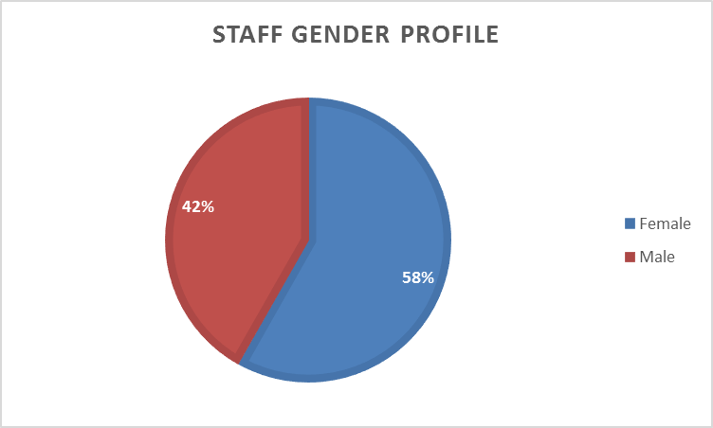

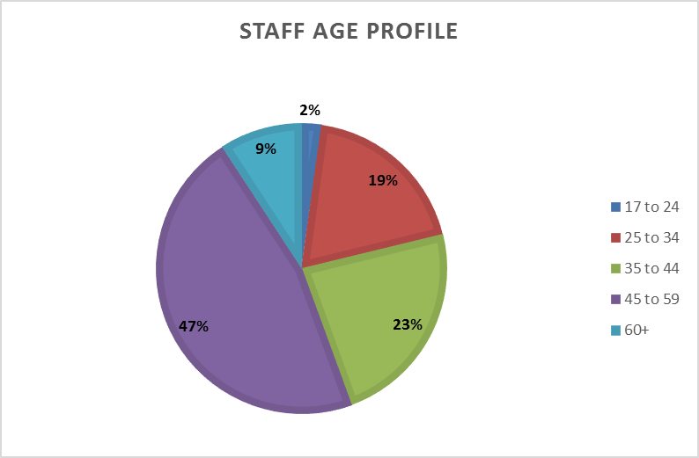

**Occupational Segregation**

Occupational segregation refers to the clustering of men and women into different levels of work (vertical segregation) and into different types of work (horizontal segregation).

Considerable work has been undertaken to align the three merged College’s grading structures to identify and address any occupational segregation. We will continue this work to ensure ongoing progress in this area.

**Vertical Segregation**

Most occupation roles are in line with the College’s gender split, with a slight bias towards Males in Support Staff supervisory roles.

**Horizontal Segregation**

There is significant gender segregation within Executive Support, Quality and Equalities, International, Organisational Development, Human Resources and Student Services roles which are largely being carried out by female employees. Some curriculum areas such as Tourism and Hospitality and Edinburgh Business School also have a significant number of female roles within these areas. While ICT and the Construction and Building Crafts roles are almost exclusively carried out by male employees.

1. Close the Gap <http://www.closethegap.org.uk>