Azure Virtual Desktops

windows virtual desktops user guide

1 - Connecting to Azure Virtual Desktop

Access Methods

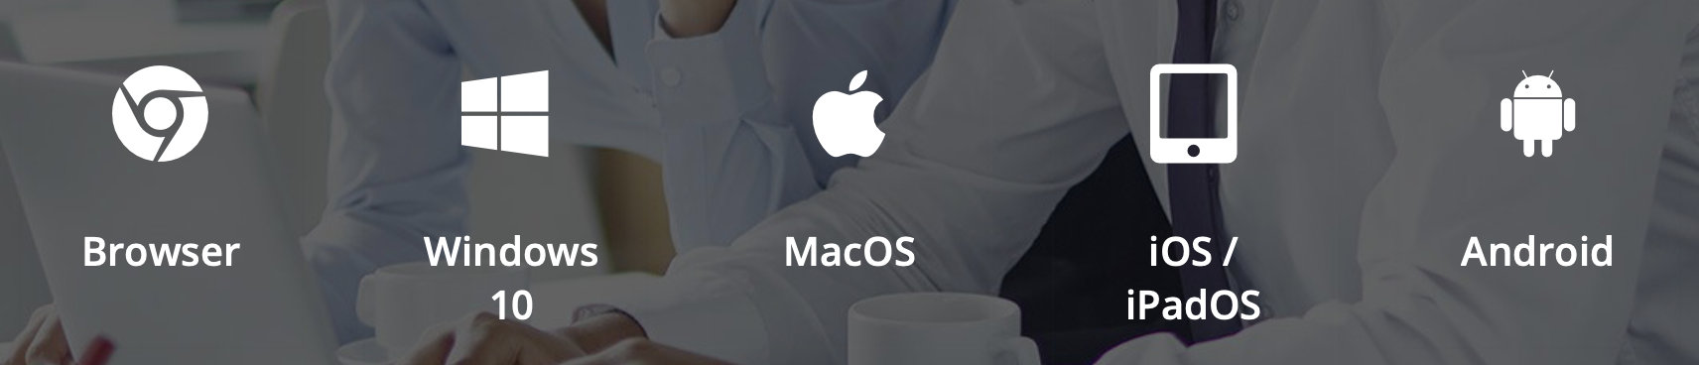

You can access AVD from a wider variety of devices than we could previously offer on the older Remote Desktop Services (RDS) platform. Windows, Apple and Android are all supported, either via a web browser or through the relevant desktop client installation, offering you the flexibility to work however you please.

How-To Guides

Choose from the links below to find the Microsoft how-to guide for your chosen device:

- Windows Desktop client
- Web client
- Android client
- macOS client
- iOS client

1 - Access using a web browser
Go to http://aka.ms/wvdarmweb
Sign in with your college email address and password

We anticipate that most of our users will be using the Windows Desktop client, so a fuller guide for those users is provided below.

2 - Getting Started with the Windows Desktop Client

- Download the Windows Desktop client from https://docs.microsoft.com/en-us/azure/virtual-desktop/connect-windows-7-10

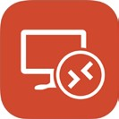
- Launch the desktop client

- Click on Subscribe
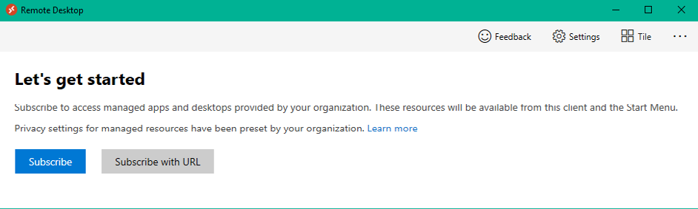

- Enter your college email address and click Next

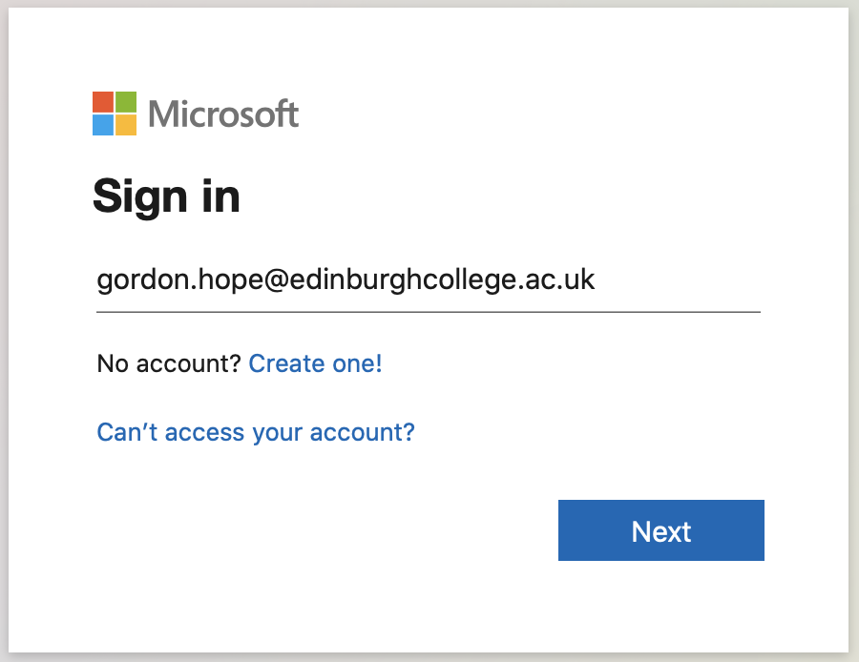

- Enter your usual college password and press Sign In

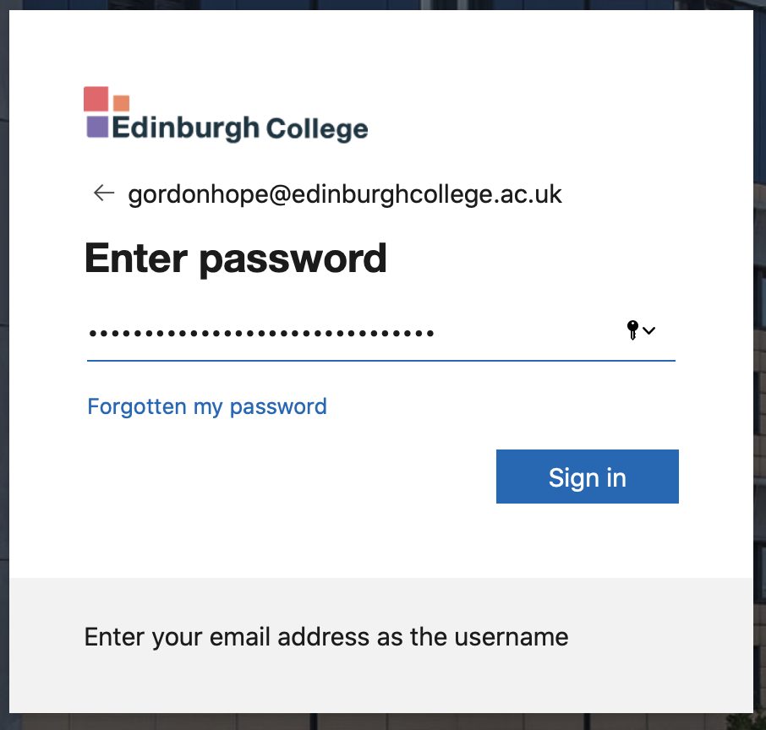

- You will be prompted for multi-factor authentication (MFA) details by whichever methods you have registered. If you have not already registered for MFA and self-service password reset (SSPR) you will be prompted to do so.

Some supporting information is provided in the Registration section of this user guide.

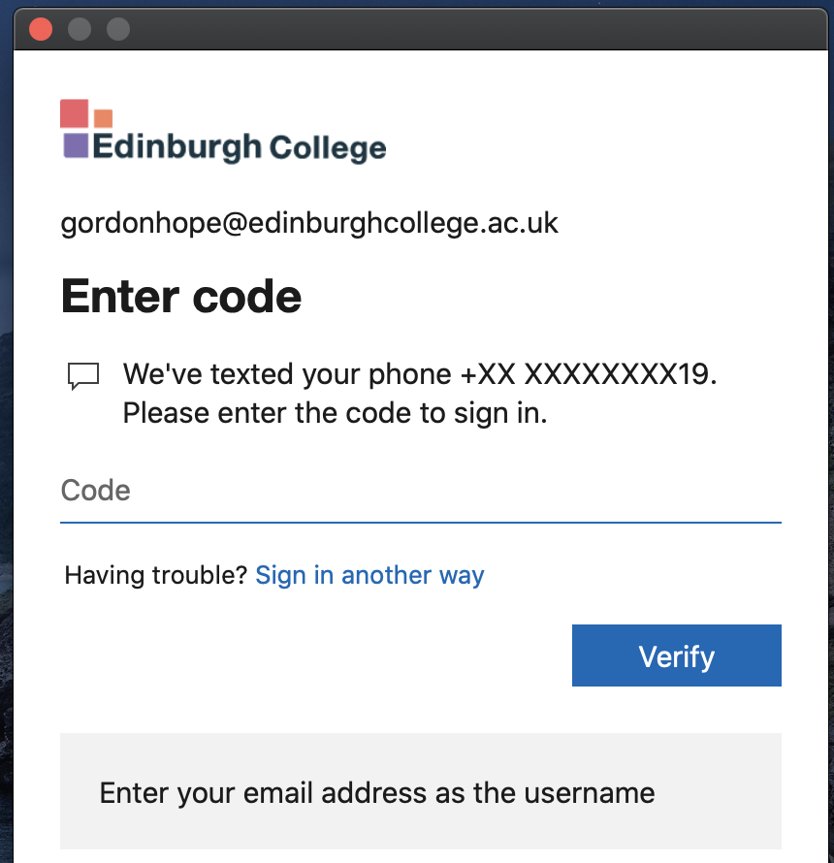

- You will then be directed to your resources page where you can select your Staff Desktop.
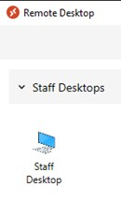

- Double-click on Staff Desktop and enter your password again when prompted, and you will be connected to your virtual desktop.

3 - Multi-factor Authentication and Self-service Password Reset (SSPR) Registration

If you are not already registered for multi-factor authentication, you will be redirected to do so before completing sign-in to Windows Virtual Desktops.

Click Next to proceed.
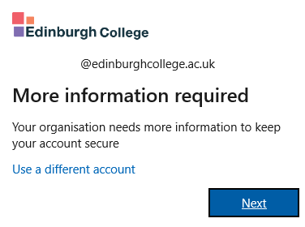

On the next page, you can choose your preferred authentication method. Either download the Microsoft Authenticator app or click ‘I want to setup a different method’ at the bottom of the window to use your mobile number.

Links to the Microsoft setup guides for configuring different authentication methods are listed below:

- Set up the Microsoft Authenticator App
- Set up text messaging

